Lecture # 20:

Objective:

* Database Connectivity (DISCONNECTED)
  + BULK QUERIES Example

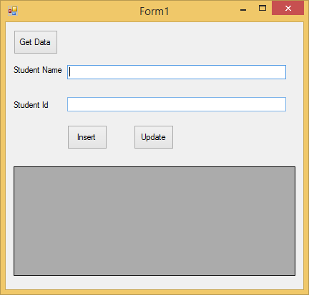

using System;

using System.Collections.Generic; using System.ComponentModel; using System.Data;

using System.Drawing; using System.Linq; using System.Text;

using System.Windows.Forms; using System.Data.SqlClient;

namespace insertupdatedelete

{

public partial class Form1 : Form

{

public Form1()

{

InitializeComponent();

}

DataSet ds = new DataSet();

private void btndata_Click(object sender, EventArgs e)

{

string strCon = @" ";

SqlConnection con = new SqlConnection(strCon); con.Open();

string query = "Select * from stdinfo"; SqlCommand cmd = new SqlCommand(query, con);

SqlDataAdapter sda = new SqlDataAdapter(cmd);

sda.Fill(ds);

dataGridView1.DataSource = ds.Tables[0];

}

private void btninsert_Click(object sender, EventArgs e)

{

ds.Tables[0].Rows.Add(textid.Text, textname.Text);

}

private void btnupdate_Click(object sender, EventArgs e)

{

string strCon = @" ";

SqlConnection con = new SqlConnection(strCon); con.Open();

string query = "Select * from stdinfo"; SqlCommand cmd = new SqlCommand(query, con);

SqlDataAdapter sda = new SqlDataAdapter(cmd); SqlCommandBuilder scb = new SqlCommandBuilder(sda);

sda.Update(ds);

}

}

}